Citi Bike Analytics

By Pam Zhao

Data Source: <https://www.citibikenyc.com/system-data>

Dataset: 2019 January - June

<https://public.tableau.com/profile/pam.z#!/vizhome/Citi_Bike_Analytics_15634371107890/CitiBike?publish=yes>

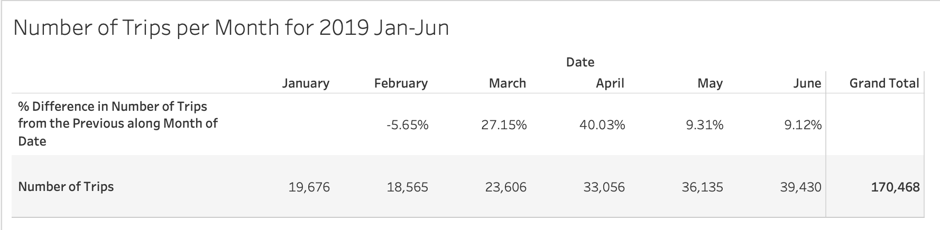

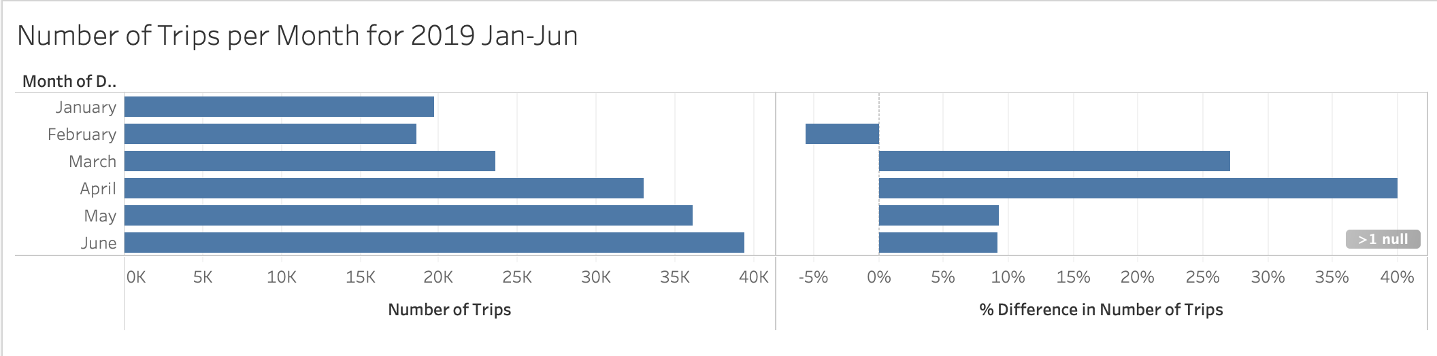

Month of June has the most of bike rides because of the warm weather.

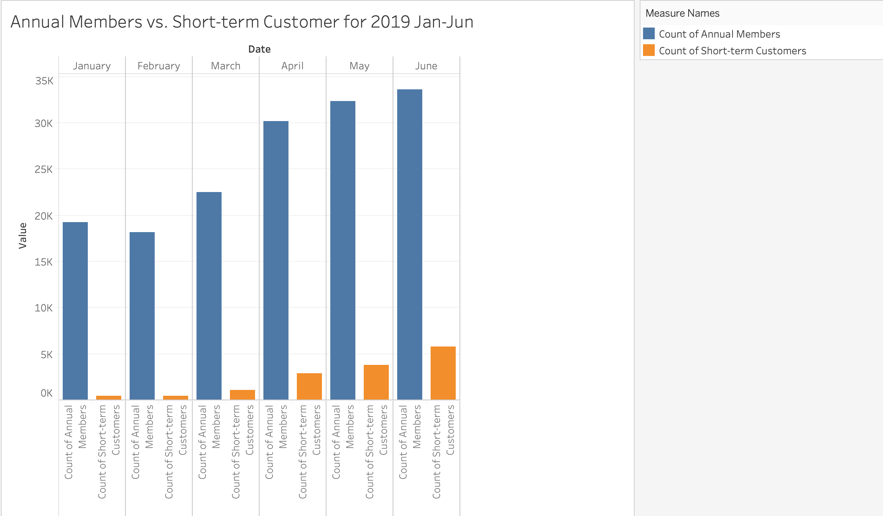

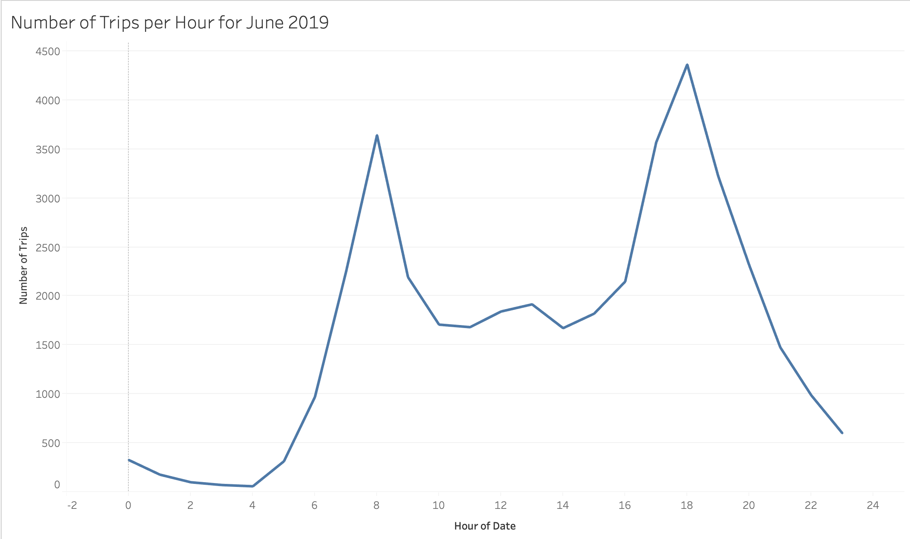

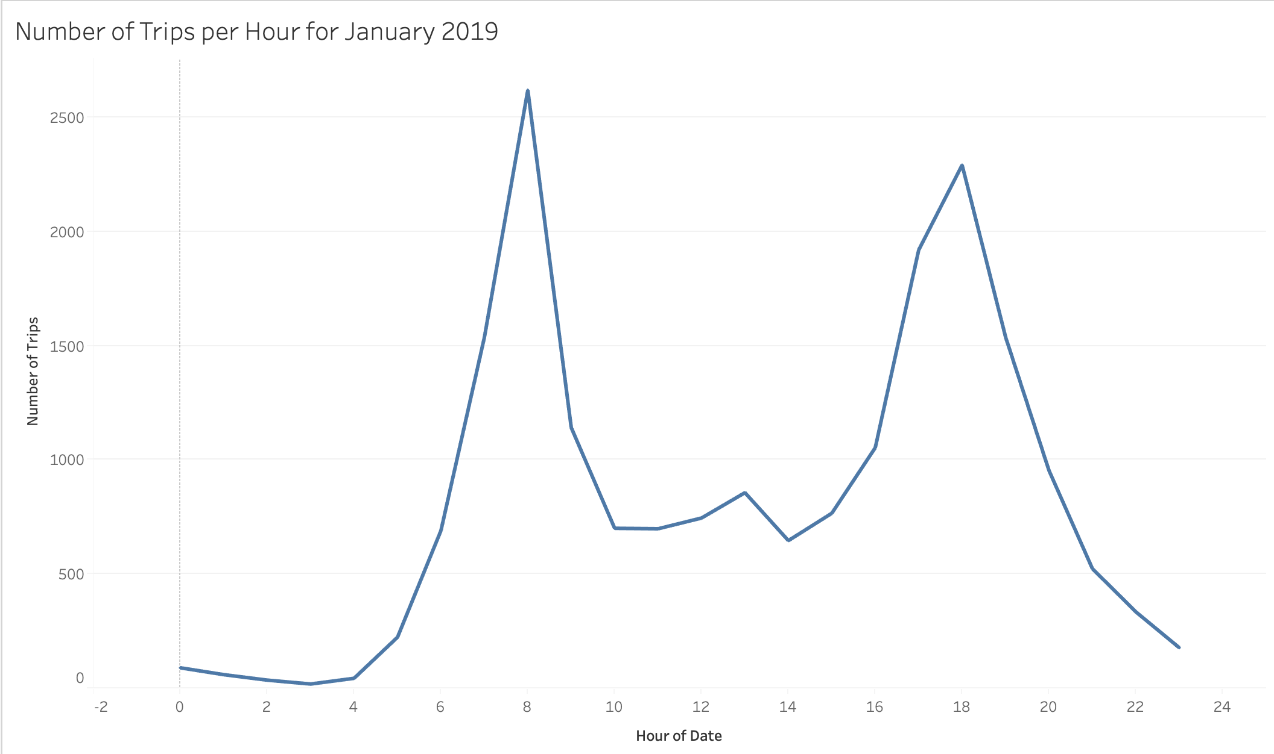

8 am and 6pm are the peak hours for using bikes in month of January and June.

